Tutorial 3(7/8/26)
1. A supermarket wants to calculate the total bill for a customer. ( NOTE: Implement using if statement, for loop, Array )

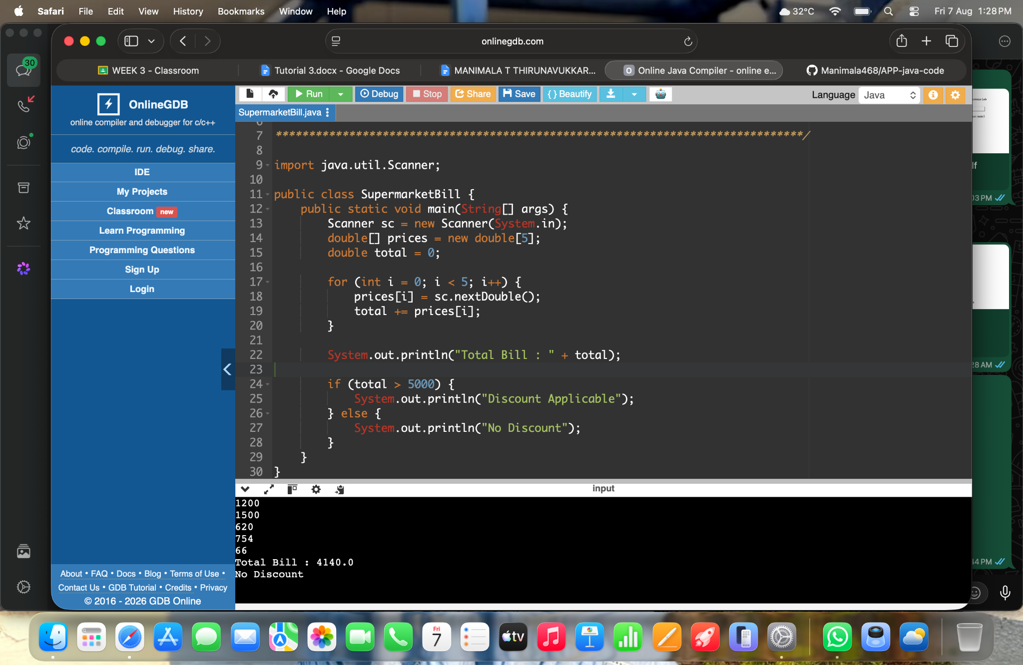

2. A school records attendance for seven days. ( NOTE: Implement using if statement, for loop, Array
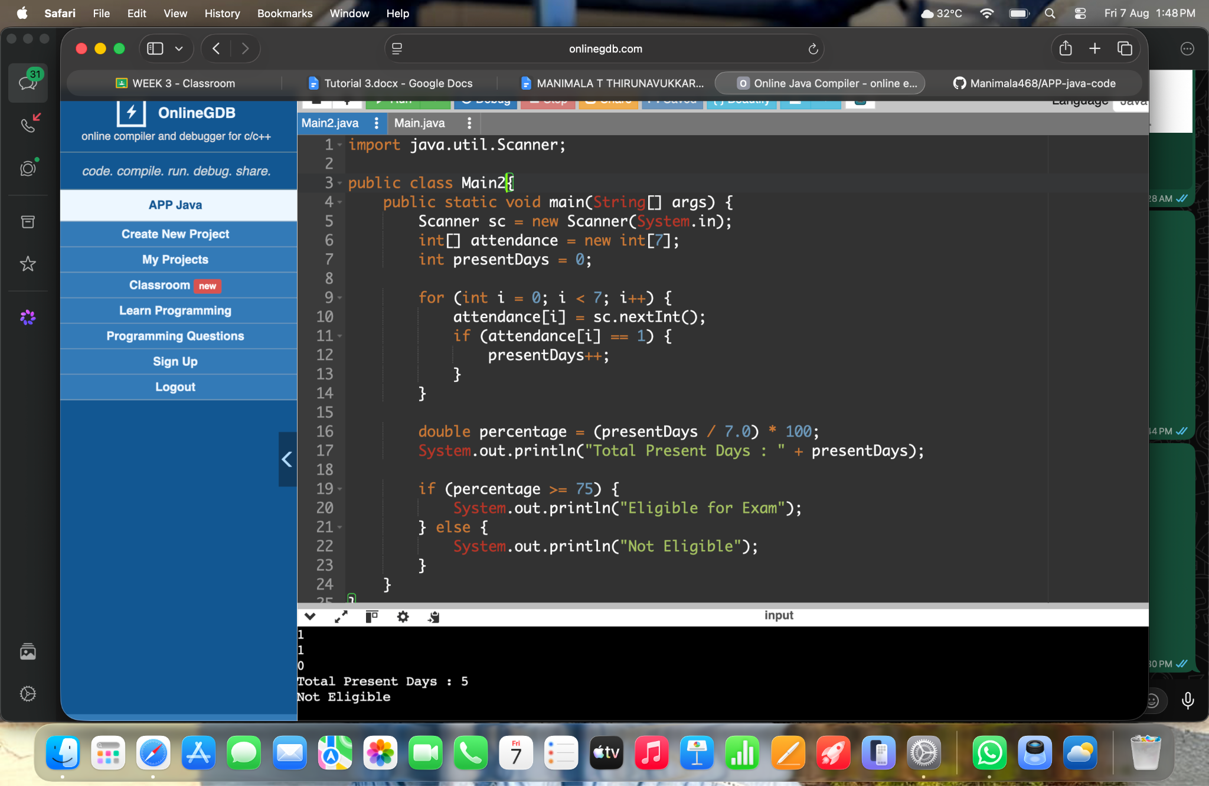

3.A company wants to store employee details using object-oriented programming.
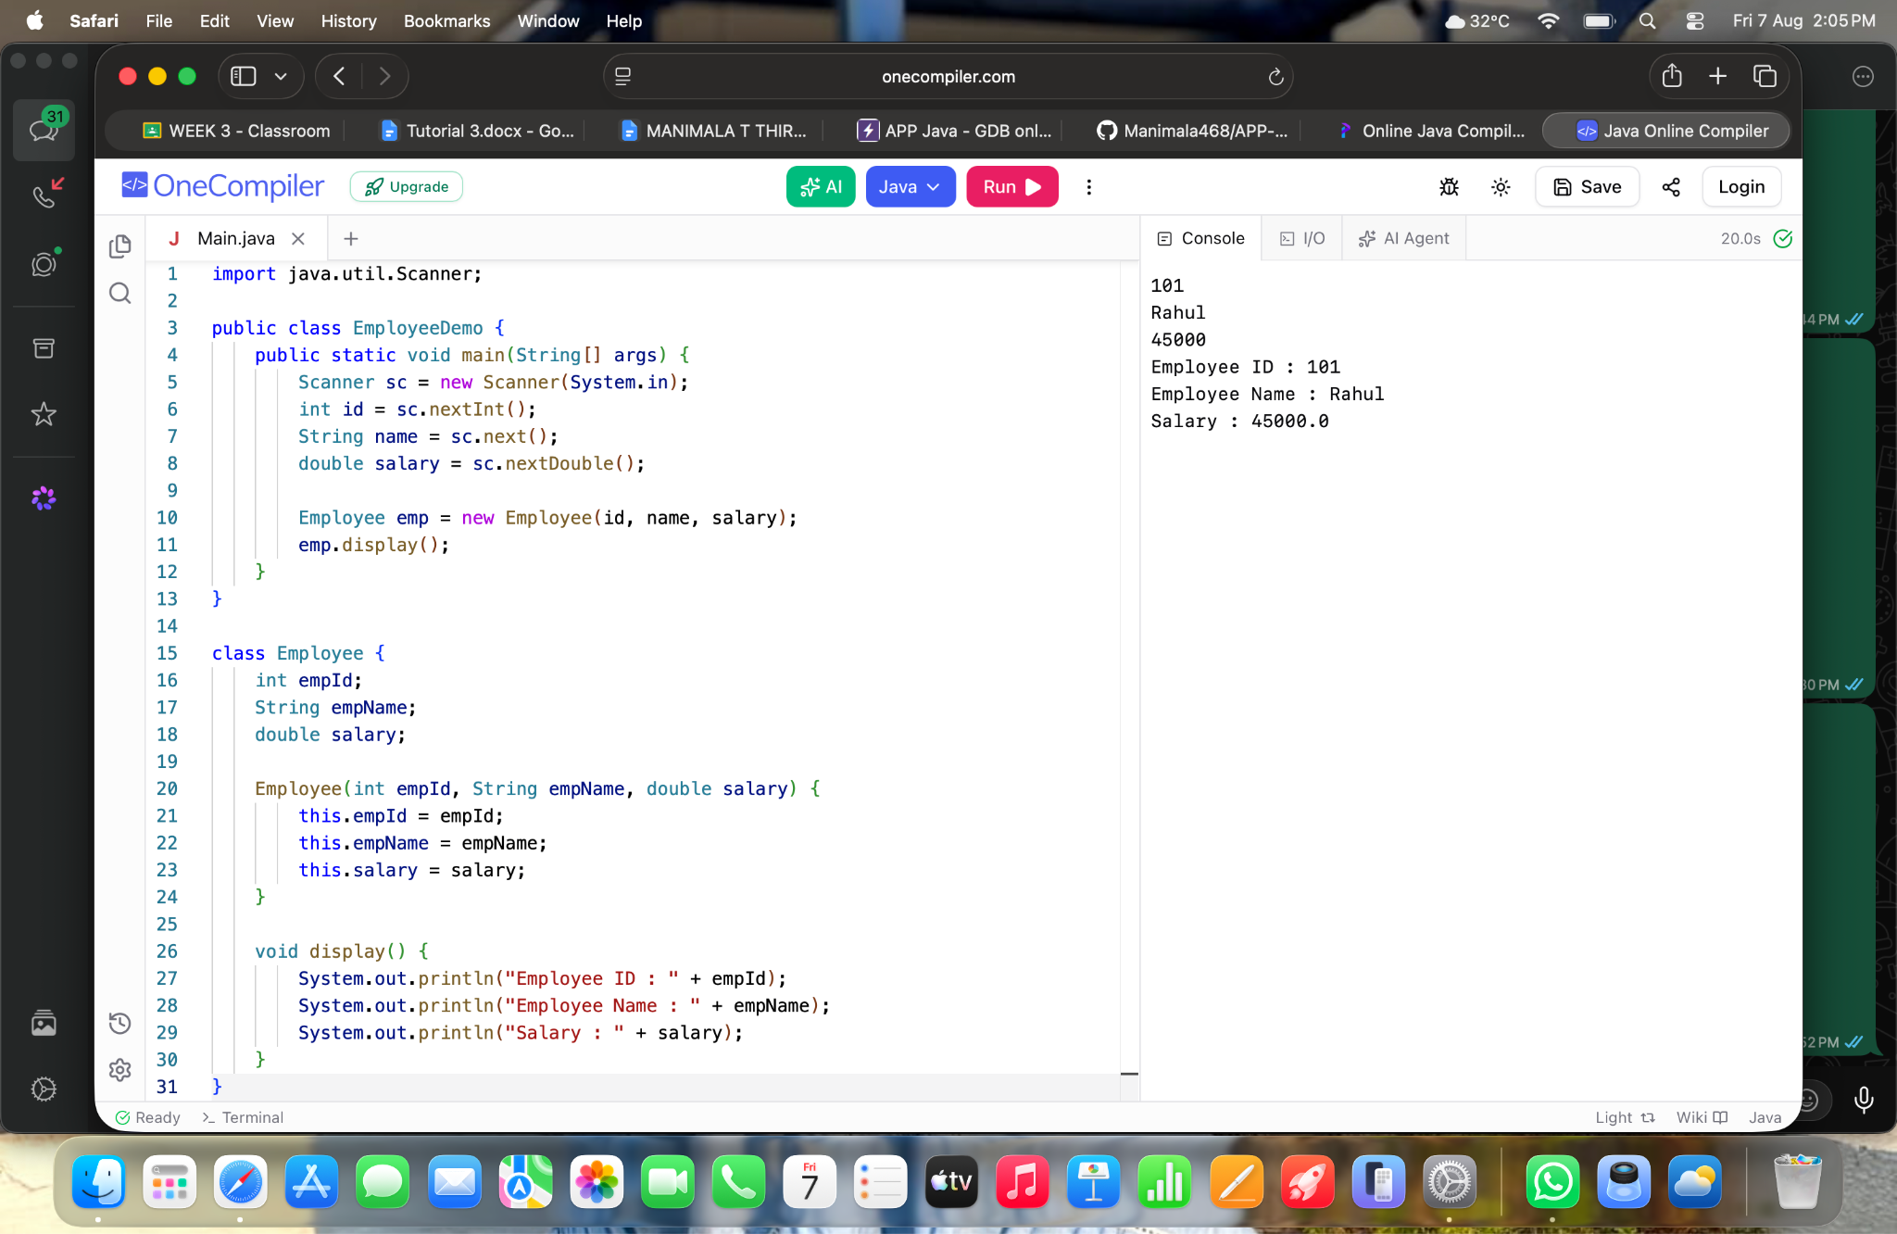

4. car showroom allows customers to register in different ways:

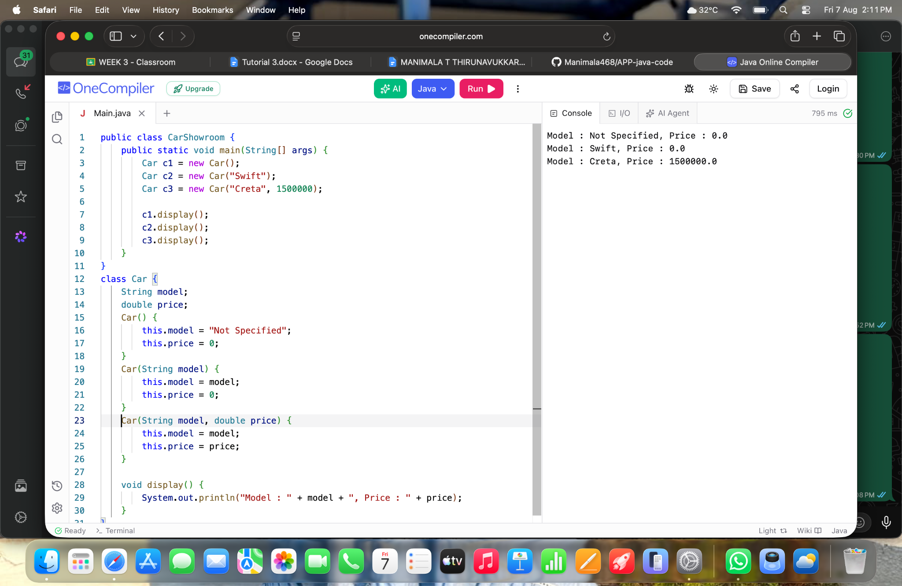

5.A geometry application should calculate the area of different shapes.(Method Overloading)
